Upgrade to ISP Session 6.0 (Classic ASP) (August, 2015)

## Compatibility

ISP Session 6.0 is normally script-compatible with previous versions except for Session.SessionID2 which has been removed and a few never used properties.

Session-Script Configuration no longer is done using global.asa Application variables. These variables must move to web.config, which you also can share with ASP.NET (if you use ISP Session 6.5)

If you install the DEMO, a cookieweb folder contains some sample config.

Existing include files, (ISPSEssion.asp) must be modified to have Server.CreateObject(“NWCTools.CSession”) instead of CreateObject (failing to do, will cause ISP Session not to run)

## SQLOLEDB

Avoid using SQLOLEDB at all as a connection provider for SQL Server. When using SQL server 2016, it even will fail to connect. Install the latest SQL Native Client on the Web Server that deploys ISP Session. The right way is “Provider=SQLNCLI11; etc…”

## Windows IIS 7 (and higher) security issues

If you decide to run your ASP scripts using an application pool identity, both DLLS and the config files, need read/execute access. E.g. if your Application Pool name is: “WebShopPool”

The identity would be (without the double quotes): “IIS AppPool\WebShopPool”

This identity must be applied tot he ISP Session path having read/execute rights.   
(Normally) C:\Program Files (x86)\ADC Cure\ISP Session

## Uninstall Older ISP Session versions

ISP Session is no longer a COM+ component. Failing to unregister, will make ISP Session 6.0 not persist the session at all.

Make very sure, the old ISP Session 5.x or older is uninstalled using the original setup.

Windows Control panel, using 'add/remove software' should do the trick.

If that failed for some reason, uninstall ISP Session 5.x by going to Component Services. (Administrative Tools menu) and remove all ISP Session packages

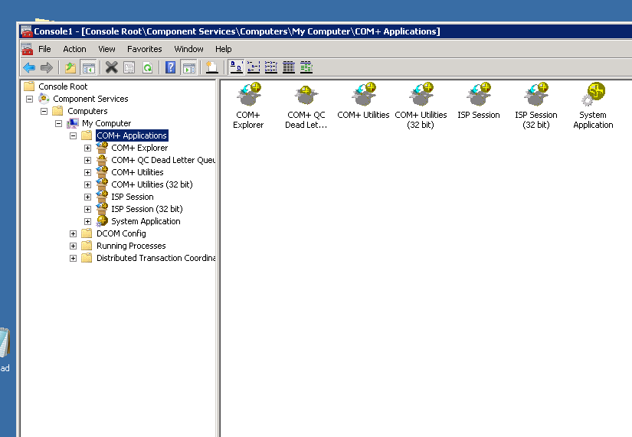

Run the SETUP for ISP SEssion 6.0

## SQL Preparation&Security

Let Setup create a *new* database for you. The older ISP session database format is not supported. There also is no conversion tool.

Make sure that the ISP Session Garbage Collection service, will have a SQL standard account having SQL admin accounts. I don’t like this, but this unfortunately is required to give ISP Session a performance boost using tempdb instead of SQL classic storage.

You need two types of accounts. One normal account, which has access to ISP Session 6.0 database.

The other is mentioned above, only meant for the garbage collection service.

Make sure the SETUP.exe control panel for ISP Session has the correct connection strings.

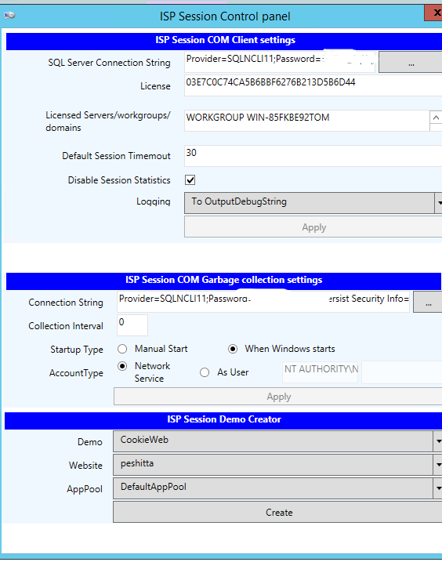

Note: For production, logging must be disabled!

### “I don’t want tempdb to be used for the session”

If this is the case, you must manually create the database and run the following script: C:\Program Files (x86)\ADC Cure\ISP Session\Resources\CreateStateScript_NOTEMP.sql

Make sure the security is applied for the ISP Session account. Now, the garbage collection service, needs no SQL account, with admin rights. Note that the ISP Session scalability drastically ‘normalizes’, because, say, using tempdb we have absurd scalability, without it we have not ☺

## Putting things in production

Copy both DLL’s from the link that you receive from me, tot he program files (x86)\adc cure\ISPSEssion\ folder.

Apply the license key. Apply the servers/domains/workgroup names you use in production/test/development.

Make sure no extra spaces are pasted into the text-box.

e.g.  
myactivedirectory.local  
MYSERVER1   
MYSERVER2  
MYWORKGROUP <- after this, NO empty lines, no spaces

Thank you for purchasing/upgrading ISP Session!